|  |
| --- |
|  |
| Procon 2 - UI Competition |
| Software Requirements |
|  |
|  |
|  |

|  |
| --- |
|  |

Contents

Introduction 3

Intended Use 3

Term Dictionary 3

General Characteristics and Constraints 4

Characteristics 4

Constraints 4

Functionality 5

Instance 5

Interface 5

Game Connection 5

Work In Progress 6

Start Page 6

"Phobar" 7

Overview 8

Game Connection 9

Player List 10

Player Profile 11

Server Settings 12

Ban List 13

Map List 14

Plugins 15

# Introduction

The purpose of this document is to define the software requirements for Procon 2, an administrative tool used to manage game servers that offer a remote protocol interface, so a user interface may be developed. If during the design of the user interface, a designer wishes to add a component of their own, they should feel free. However, please do not omit any functionality listed in this document.

We're looking for a general **layout** and **color scheme** for this project. While the program will initially be developed as a desktop application, we are looking to expand to a web application as well - please keep this in mind as you are developing the user interface. Currently, the application draws a lot of inspiration from Google Chrome. We're trying to show people what we believe they want to see and hide the seemingly hundreds of options or information we had in the previous versions.

All names for components in this document are subject to change. If you feel another name would better describe the page, component, or control, please include this in your design with a footnote recording the change.

# Intended Use

Procon 1 currently supports a limited set of games and is highly bound by restrictions created by those games. Procon 2 was developed with the intention of removing the connection between the user interface and the game, providing a generic enough user interface so that the user could potentially manage any type of game. Ultimately, Procon 2 will perform the same functions that Procon 1 does, but with a better user interface (and possibly more ways to perform a single action as well). Also, if you want to, you can include a logo for Procon 2 with your mock-up.

* Current version of Procon 1: <http://phogue.net/procon/procon_1.1.3.1.zip>.
* Questions/Feedback: <http://www.phogue.net/forumvb/forumdisplay.php?35-UI-Competition>.
* Submit a mock-up: <http://jobs.designcrowd.com.au/job.aspx?id=29497>.
* Current Procon 1 logo: <http://phogue.net/procon-frostbite/>.

# Term Dictionary

The following is a list of terms that are used in the document. This purpose of this section is to explain the term in Layman's terms.

|  |  |
| --- | --- |
| Account | A login for users when connecting to a remote interface. |
| Ban | A person who has been temporarily or permanently removed from the game. |
| Game Connection | The connection to the game server used by Procon. |
| Game Server | A server a user would connect to when playing a game online. |
| Group | A set of permissions. Accounts are linked to groups to give or restrict certain permissions to or from those accounts. |
| Instance | The actual program in it's entirety. |
| Layer | A user connects to a layer using the remote interface. |
| Local Interface Personal Interface | Allows the user to operate the program directly from his/her computer. |
| Map | A level, per say, that the game contains. |
| Package | Portions of Procon 2 that may be downloaded to update, enrich, or alter the program. |
| Permission | Whether a user is able to perform a specific action. |
| Player | A person who is playing a game on a game server. |
| Player Id | A way to uniquely identify each player per game. |
| Plugin | A user-developed add-on to Procon 2. |
| Remote Interface | Allows the user to connect to another instance of Procon running on another machine and operating it remotely. |

# General Characteristics and Constraints

We would like to create an interface that shows the user what they want when they want it; aside from mind-reading, this is pretty difficult. This requires us to put constraints on the design of the user interface to a point so that usability is not lost during design. The first list describes general characteristics of the program. The second list describes constraints related to the user interface.

## Characteristics

* An **Instance** contains 1 Local Interface and 0 to many Remote Interfaces.
* An **Instance** contains 0 to many Packages.
* An **Instance** contains many Options.
* An **Interface** contains 0 to many Game Connections.
* An **Interface** contains 0 to many Groups.
* A **Game Connection** contains 0 to many Players.
* A **Game Connection** contains 1 to many Maps.
* A **Game Connection** contains 0 to many Bans.
* A **Game Connection** contains 0 to many Plugins.
* A **Game Connection** contains 0 to many Settings.
* A **Group** has 0 to many Accounts.
* A **Group** has many Permissions.
* An **Account** has many Player Ids.

## Constraints

* All actions should be able to be performed in 4 steps or less.
* Mouse-driven design is preferred, but keyboard driven design is allowed.
  + Context menus are nice.
  + Drag and Drop is also nice.
* Information should be displayed in as concise a way as possible.
  + Seemingly non-essential information can be omitted to be more precise.
  + Detailed information should be available upon request.
* The interface should be able to fit in various window sizes.
  + The minimum window size is 1024 x 768.
  + The maximum window size is 1920 x 1200.
* The interface should not cater to and display specific information to any one game.

# Functionality

This portion of the document will attempt to describe what functionality needs to be included in the user interface. Some areas, such as options and settings, cannot be fully described, as the functionality included in these portions changes under various conditions.

## Instance

The user needs to be able to...

* Connect to and disconnect from layers (using a remote interface).
  + Requires an Ip, Port, and Password.
  + Needs to handle invalid information.
* Swap between local and remote interfaces.
* Manage options related to the instance.
  + **We are partial to Google Chrome's option tab.**
  + The language of the program.
  + Sandbox options (allowed to create files, open connections, etc).
* Manage options related to the layer.
  + Ip and Port the layer binds to.
  + Whether the layer is on / off.
* Download and install packages.
* View the twitter/blog feed.

## Interface

The user needs to be able to...

* Connect to and disconnect from game servers (using a game connection).
* Create, delete, and rename accounts and groups.
  + Alter permissions of groups.
  + Alter password and player ids of accounts.

## Game Connection

The user needs to be able to...

* View, Chat to, Move, Kick, Ban, and Unban players in the player list.
  + **We are partial to a tiled format for the player list.**
  + More than one layout for the player list is also preferred.
* View, Add to, Remove from, and Alter maps in the map list.
* View, Add to, and Remove from the ban list.
* View, enable, disable, and alter settings of plugins.
* View and alter settings related to the game server.
* View and filter the chat of players.

# Work In Progress

Procon 2 has been in development since December 2010. As such, several iterations of the user interface have been created (and ultimately found not worthy). To attempt to help out the designer, the rest of the document will contain wire-frames for various "pages" and descriptions containing the functionality that was included on them. **Important:** the following mock-ups are not guidelines for the final design of Procon 2. However, they emphasize functionality that we've come to think would be useful in the final mock-up.

## Start Page

When the user opens Procon 2 for the first time, a lot of setup will need to be done. However, this setup is mostly a one-time-only ordeal. To simplify this for the user, we've added a start page that explains to the user the different ways Procon 2 can be used.

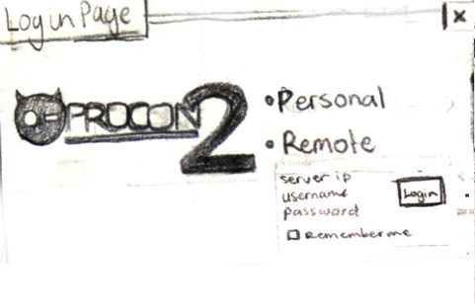

Functionality included on this page:

* Begin using the Personal (Local) interface, or
* Connect to a Remote interface (displays an error if connection fails).
* Ability to bypass the page in the future by selecting "Remember Me."

## "Phobar"

This is a control that we wish to remain accessible during most of the program's lifetime-pretty much on every page except the login page. The Phobar allows the user to quickly access any piece of functionality in the program by typing out a command. We wish to have some sort of auto-complete feature, as well as a preview of what will happen if the command is executed.

**Note:** the name of this component is highly debatable; it is simply named as such for easy reference.

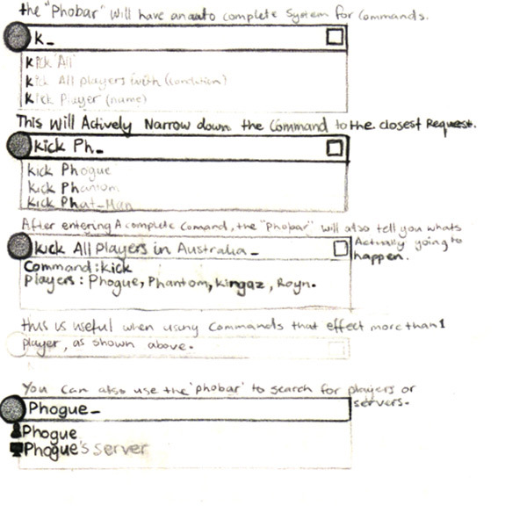

Functionality included on this page:

* A place to enter the command.
* Auto-complete suggestions.
* Preview of the results of the action.

## Overview

The overview page is used as the "home page" for this mock-up. The user can see all the game connections he/she has created, and create new or delete game connections. The twitter feed is displayed on the right side as well, but its placement is not permanent. The graphs at the bottom represent various statistics of the connection that is currently selected from the list.

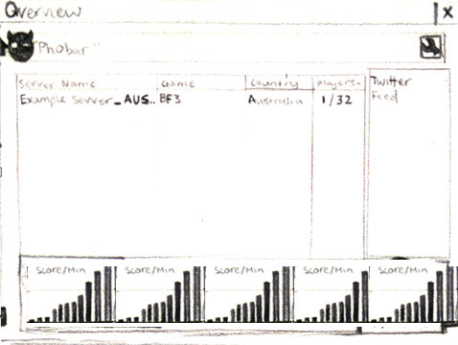

Functionality included on this page:

* Use the "Phobar."
* Add new connections.
* Delete existing connections.
* View a brief overview of a specific connection.
* Ability to go to a game connection's page.
* View the twitter feed.
* Manage the instance settings.

## Game Connection

This page is dedicated to each game connection. You can see the tabs across the top breaking up the administration into players, settings, bans, maps, and plugins. Also, you can see the chat window across the bottom, which displays chat from the players and allows you to send chat as well.

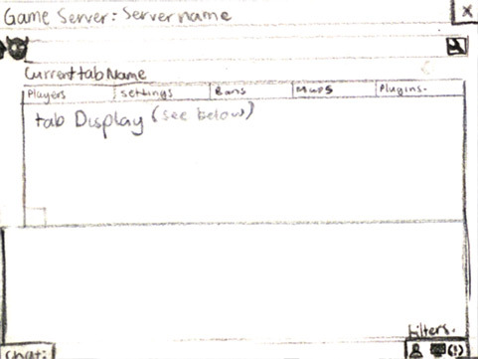

Functionality included on this page:

* Use the "Phobar."
* Various actions, depending on which tab is selected.
* View and filter the chat of players.

## Player List

This is a subset of the window above, where the words "Tab Display (see below)" are written. Originally, the player list was a tabular list of players which showed score, ping, kdr, kills, deaths, team, squad, and etc. However, most of this information was rarely used. Therefore, we decided to display the players in blocks to utilize the screen space saved when removing irrelevant information.

Important players are placed at the top, with more information shown about them, whereas the other players are placed lower in the grid with only their name. The graphs on the right are controls for whose information gets shown and whose doesn't.

Some other information that could be included on this page might be an icon, representing that the player is linked to an account in Procon 2.

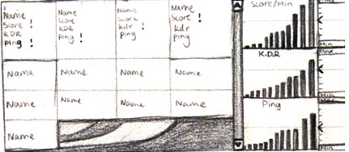

Functionality included on this page:

* View, Chat to, Move, Kick, and Ban players in the player list.

## Player Profile

The page represents a player's detailed information. Because the player list contains a reduced amount of information, a new area needed to be created where all of that player's information could be shown. The information on this page may vary depending on the game that the player is playing.

Some information that might be worth including would be the account the player is linked to, if any. This panel is displayed inside the player list, similar to the last window, whenever the player selected.

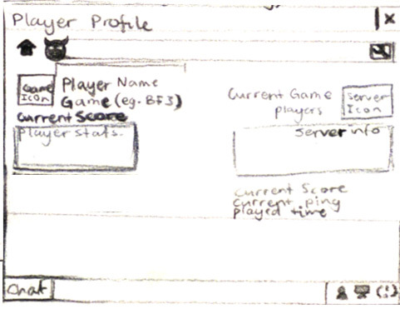

Functionality included on this page:

* View, Chat to, Move, Kick, and Ban a player.
* Link the player to an account.

## Server Settings

In Procon 1, we tried to display all the variables in a neat nice way, but as we expanded to new games, each game didn't have the same settings. This caused us to rewrite the page for each specific game, which was very time consuming and horrible to manage. In Procon 2, we're generalizing this down to a list. When an item is selected, it's information is displayed to the right, with the ability to change the value of said variable. There is also a filter to narrow down the options.

As with the other windows, the information on this page will change depending on the game type. This panel would be displayed under the "Settings" tab. **Note:** the written text "Commandlist" should actually say "Settings List."

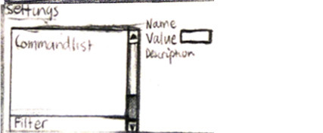

Functionality included on this page:

* View and alter settings related to the game server.

## Ban List

Procon 1 didn't have many issues with the ban list. For this mock-up, we pretty much kept it the way it was. **Note:** the written text "Ban" in picture should actually say "Unban."

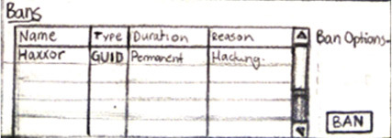

Functionality included on this page:

* View, Add to, and Remove from the ban list.

## Map List

Similar to the ban list, the map list in Procon 1 didn't have that many issues. Therefore, we pretty much kept it the same.

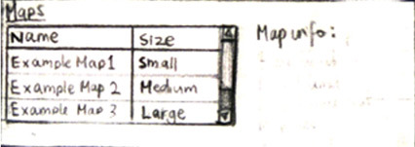

Functionality included on this page:

* View, Add to, Remove from, and Alter maps in the map list.

## Plugins

The plugins page is somewhat controlled by the plugin itself. However, the user needs an overview of what plugins are running, which one to edit, and other information. Mostly, it's the same.

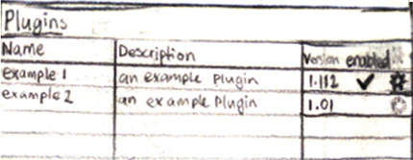

Functionality included on this page:

* View, enable, disable, and alter settings of plugins.